Sample Social Media Posts

Here is sample text to use in your social media outreach (Facebook, Instagram, Twitter) to help advertise the Double Up Food Bucks program at your outlet. Download the high-resolution images shown here from the NMFMA website separately via the Resources section of the members website (www.newmexicofma.org) after you log in.

Facebook
- Want to double your food dollars? You can with [YOUR OUTLET] Double Up Food Bucks! [YOUR URL]
- Double your SNAP/EBT food dollars with Double Up Food Bucks! Find us at [YOUR URL, ADDRESS, HOURS OF OPERATION]
- You can get FREE fruits & veggies with Double Up Food Bucks! at [YOUR URL, ADDRESS, HOURS OF OPERATION]
- It’s quick & easy to bring home FREE fruits & veggies with your SNAP/EBT card. Visit [YOUR URL, ADDRESS, HOURS OF OPERATION]

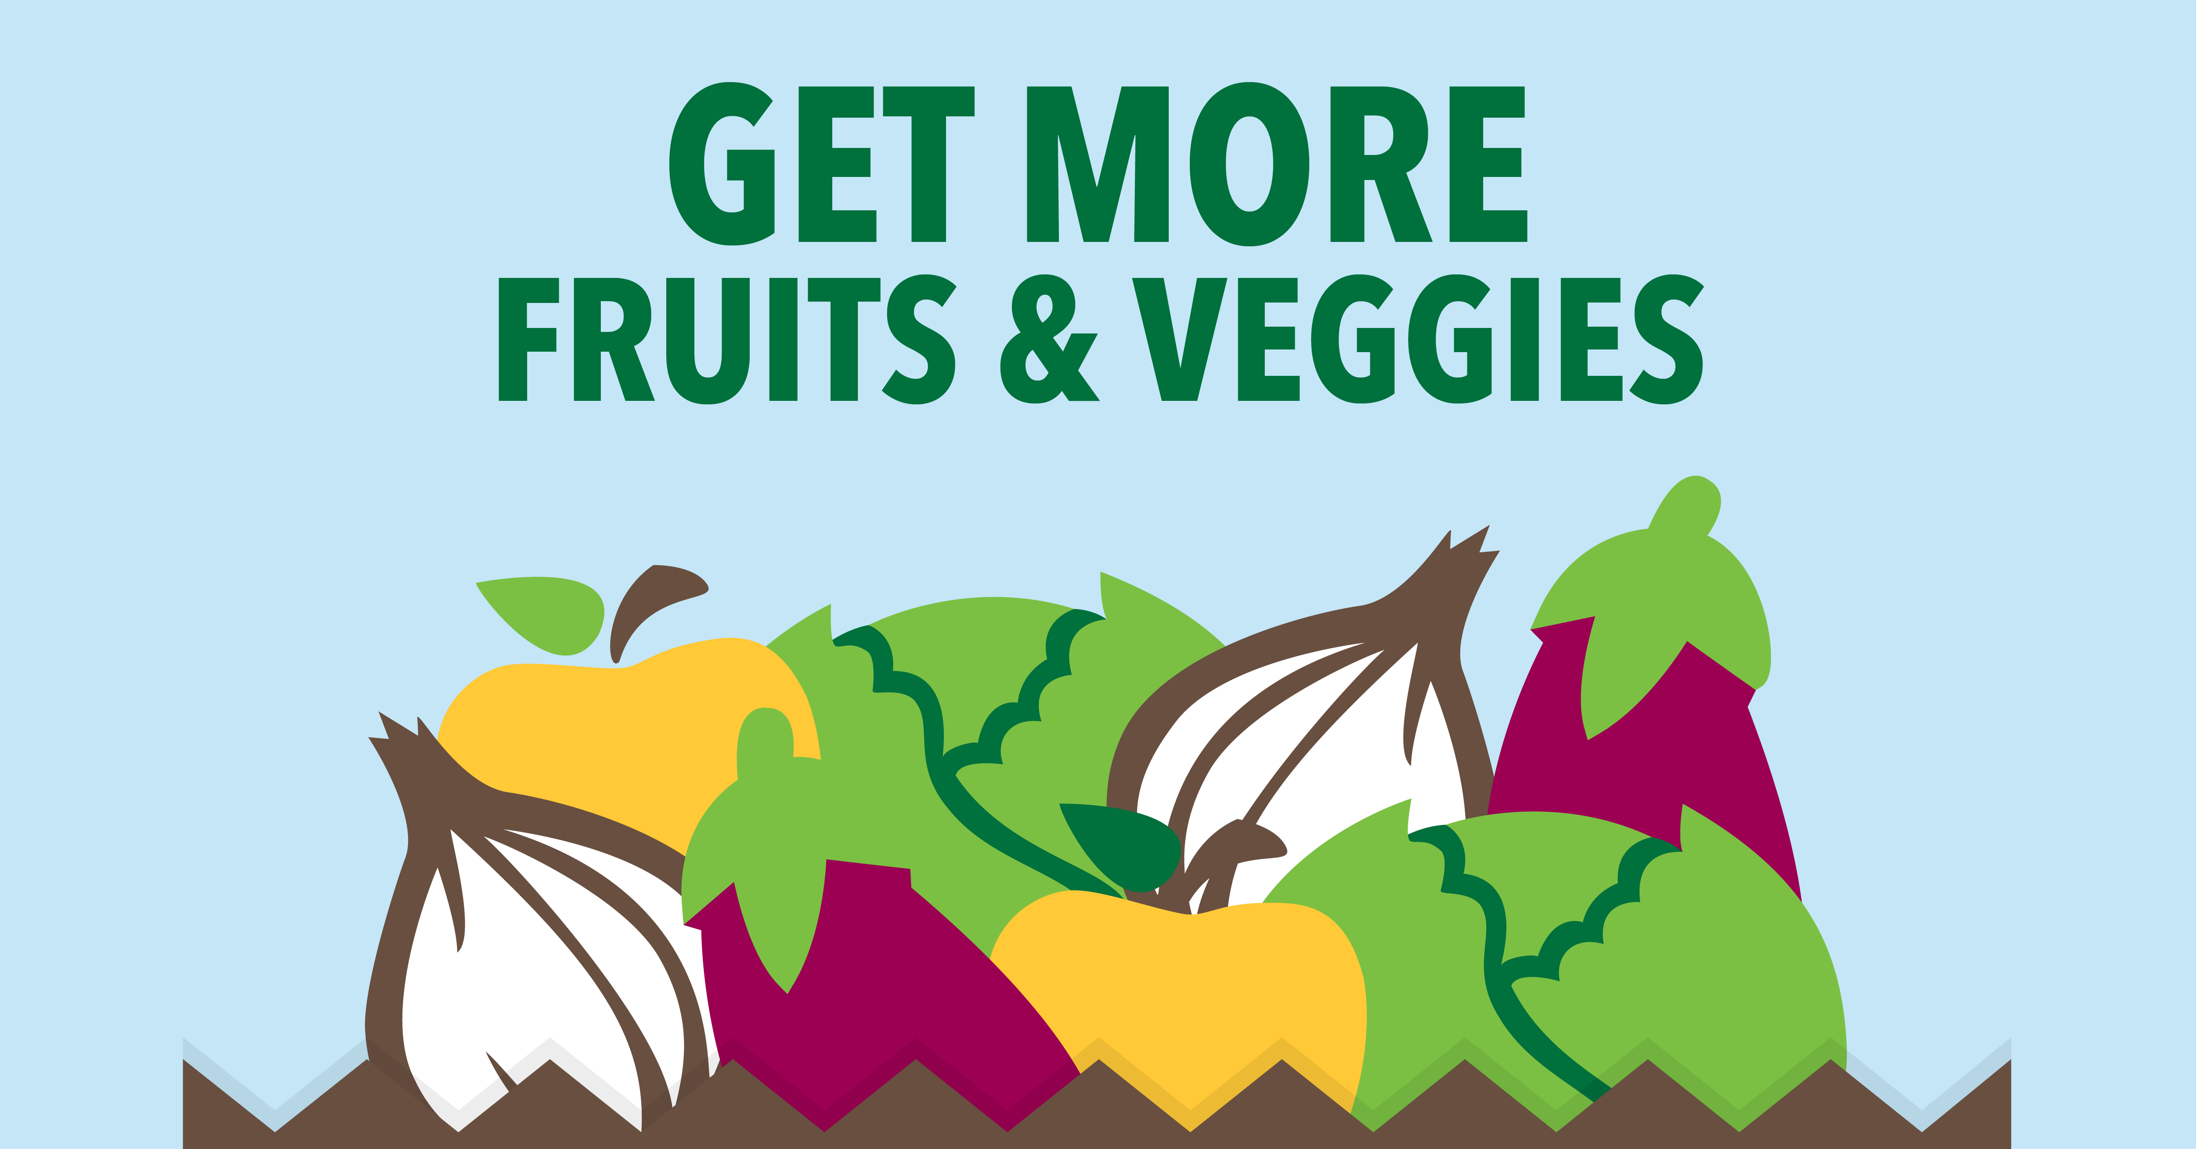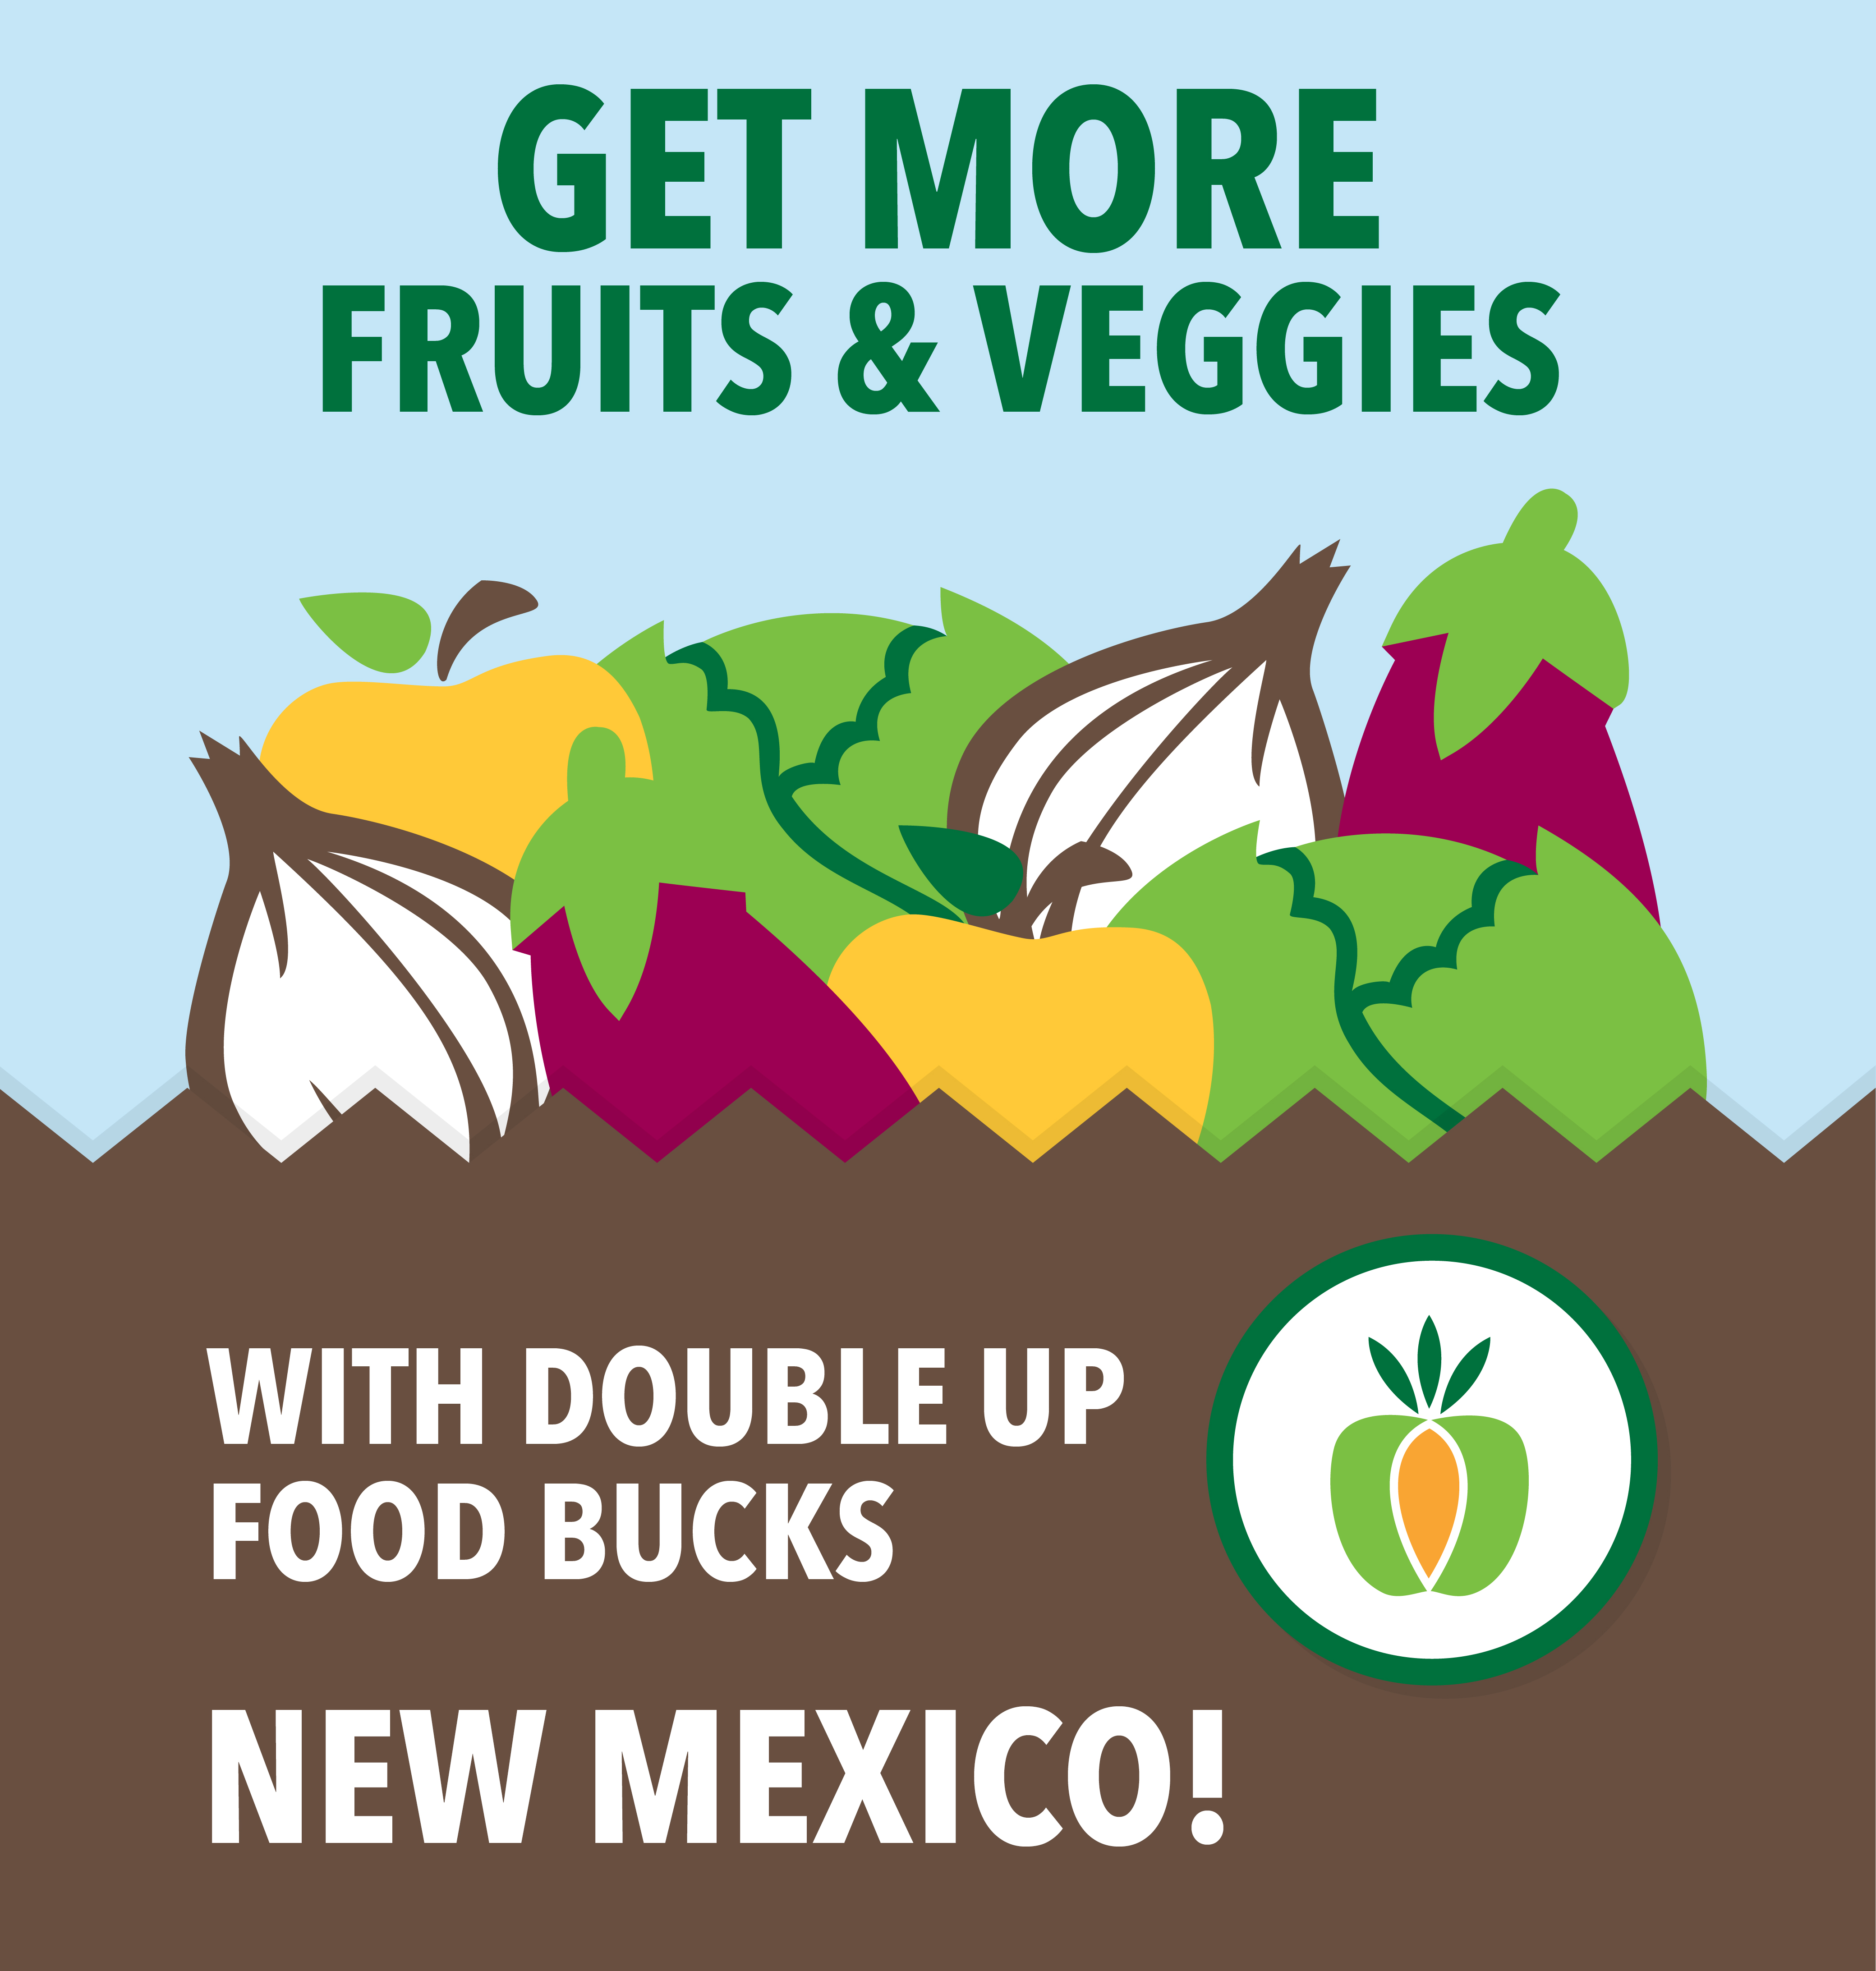

Instagram
- Want to double your food dollars? You can with New Mexico Double Up Food Bucks!
- You can get more fruits & veggies with Double Up Food Bucks at [YOUR OUTLET NAME]. Check out our website for our location and hours of operation!
- Hashtag suggestions: #DoubleUpNM #SNAPEBT #NewMexicoSNAP #DoubleUp #HealthyNM

Twitter
- Want to double your food dollars? You can with New Mexico #DoubleUp Food Bucks! [YOUR URL].
- Double your EBT dollars with #DoubleUp Food Bucks! Visit Us! [YOUR URL]
- See how you can get a dollar-for-dollar match in fruits & veggies with #DoubleUp! [YOUR URL]
- See how you can get FREE fruits & veggies with #DoubleUp Food Bucks! Learn more [YOUR URL]
- #DoubleUp is helping more New Mexican shoppers double EBT dollars. Find out how: [YOUR URL]

